GETTING TO KNOW YOUR DUALSHOCK 4

LAB 1
SECTION

SUBMITTED BY:
Simon Samuel

SUBMISSION DATE:
9/22/2025

Problem
The goal of this lab was to get familiar with the DualShock 4 controller and see how its sensors record data. During the lab we collected accelerometer and gyroscope values in specific positions and movements to understand how the numbers connect to what the controller is accomplishing. Part of this lab was to figure out how to properly use the Cygwin terminal when compiling and running code.
Analysis
In this problem the tester/researcher gave input by holding the controller in specific positions or by moving the controller in certain situations. What was output was valued, based on gravity, that the accelerometer obtained while recording for three different axes, x, y, and z, given positions in millisecond intervals. The given outputs for the x and y variables shifted between -1 and 1 depending on the orientation of the controller, while the z variable remained close to zero, until the tests where the controller was moved.
Design
First, I connected the DualShock 4 controller using Bluetooth and used the ds4rd.exe program with the “-t” and “-g” flags. I looked at the instructions for how to properly navigate files, as well as compiling instructions. During the problem, I created six files of data and named them based on the instructions, which represent each orientation the controller was in.
Flat 1 and Flat 2 represent when the controller is laid out horizontally on the table, both on its regular side as well as on its top. While Front 1 and Front 2 refer to the orientation of the front of the controller, 1 being the front of the controller pointing up and 2 the front of the controller pointing downwards. For Custom 1 and Custom 2, I was able to choose a simple motion, the motion I chose was a simple tilting motion of the controller. For each of these tests, the data was redirected into .csv files.
Testing
During the lab to test the solution and make sure the data was correct, I ran a few practice runs where I personally just messed around with the controller while it recorded data. After data was collected I went through it to make sure certain values were correct. This proved to be useful because when it came down to testing the joystick, I found that my controller had a broken right joystick that didn’t record any values.
Comments
In this lab I learned how to properly use Cygwin and Visual Studio Code, which will help me in future labs. I also learned how to record data, as well as analyze it for proper values and correctness. When I first saw the irregular values for the broken joystick, I was really confused, so it was a great help to have the TA’s work with me to figure out what the problem was.

Lab 1 Companion Homework
Old Computers:
MITS Altair 8800 - Input: switches, Output: LEDs lights, RAM: 256B-64KB (2,048-524,288 bits), CPU: Intel 8080.
MOS KIM-1 - Input: hex keypad, Output: LED display, RAM: 1KB-4KB (8,192-32,768 bits), CPU: MOS 6502.
Apple 1 - Input: keyboard, Output: video, RAM: 4KB-8KB (32,768-65,536 bits), CPU: MOS 6502.
IBM PC 5150 - Input: keyboard, Output: monitor & floppy, RAM: 16KB-640KB (131,072-5,242,880 bits), CPU: Intel 8088.
Apple Macintosh - Input: keyboard & mouse, Output: monitor, RAM: 128KB (1,048,576 bits), CPU: Motorola 68000.
Base Conversion:
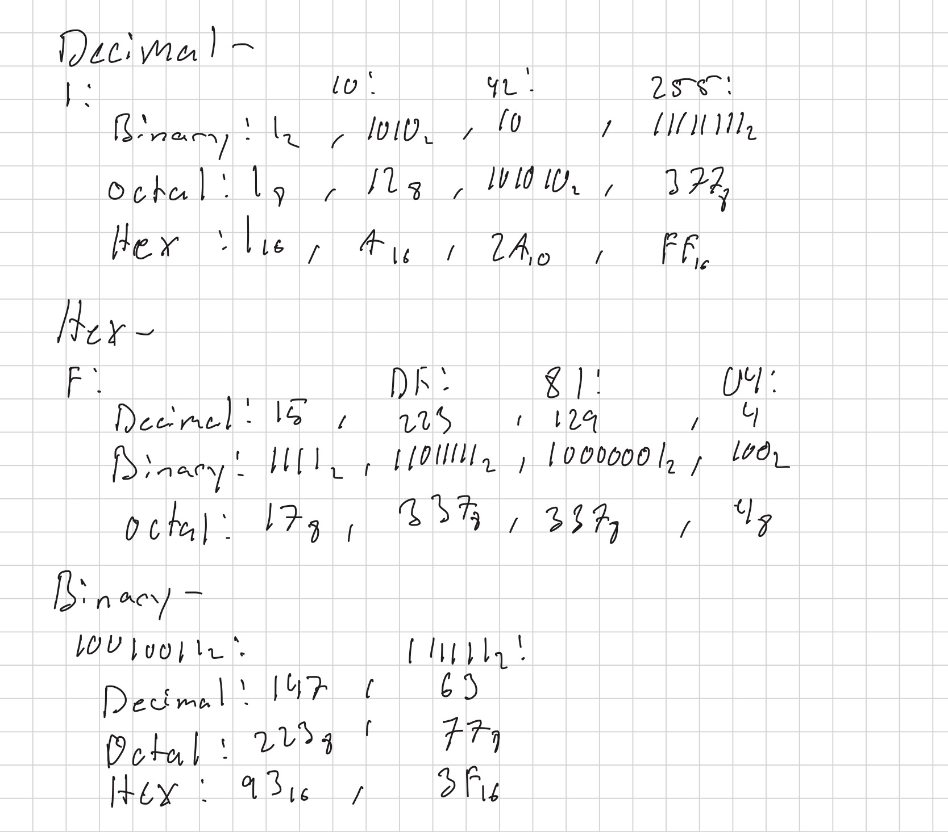

Exploration:
Q: What do you think each column of data represents?
A: I think that the first column is time, and the other three are readings for x, y, and z axis.
Q: How does this relate to the flags (-t and -g)?
A: “-t” adds time, “-g” gives us sensor data.
Q: What unit of measure are the data in?
A: most likely in g (gravity).
Q: On each plot, explain what is going on?
A: The flat/front plots show the effect of gravity depending on orientation. The custom plots show a repeated tilting motion that makes the graphs look like waves.
4. Joystick Calibration
Q: What are your vertical and horizontal joystick equations?
A: (Raw Value - Center) / Range, to get values between -1 and 1.
Q: Are they similar or not? Why?
A: Yes, both work the same way but on different axes.
Q: What did you find as the center point?
A: It was close to 0, but not exact.
Q: What could cause the center to not be 0?
A: Small errors in the hardware or in the calibration.
Q: What could you change to make the center be 0?
A: Recalibrating it in its software or adding a dead zone.

Scatter Plots:

Flat1: Controller Upright

Flat2: Controller Upside Down

Front1: Light Bar Up

Front2: Light Bar Down

Custom1: Tilting Motion

Custom2: Tilting Motion

